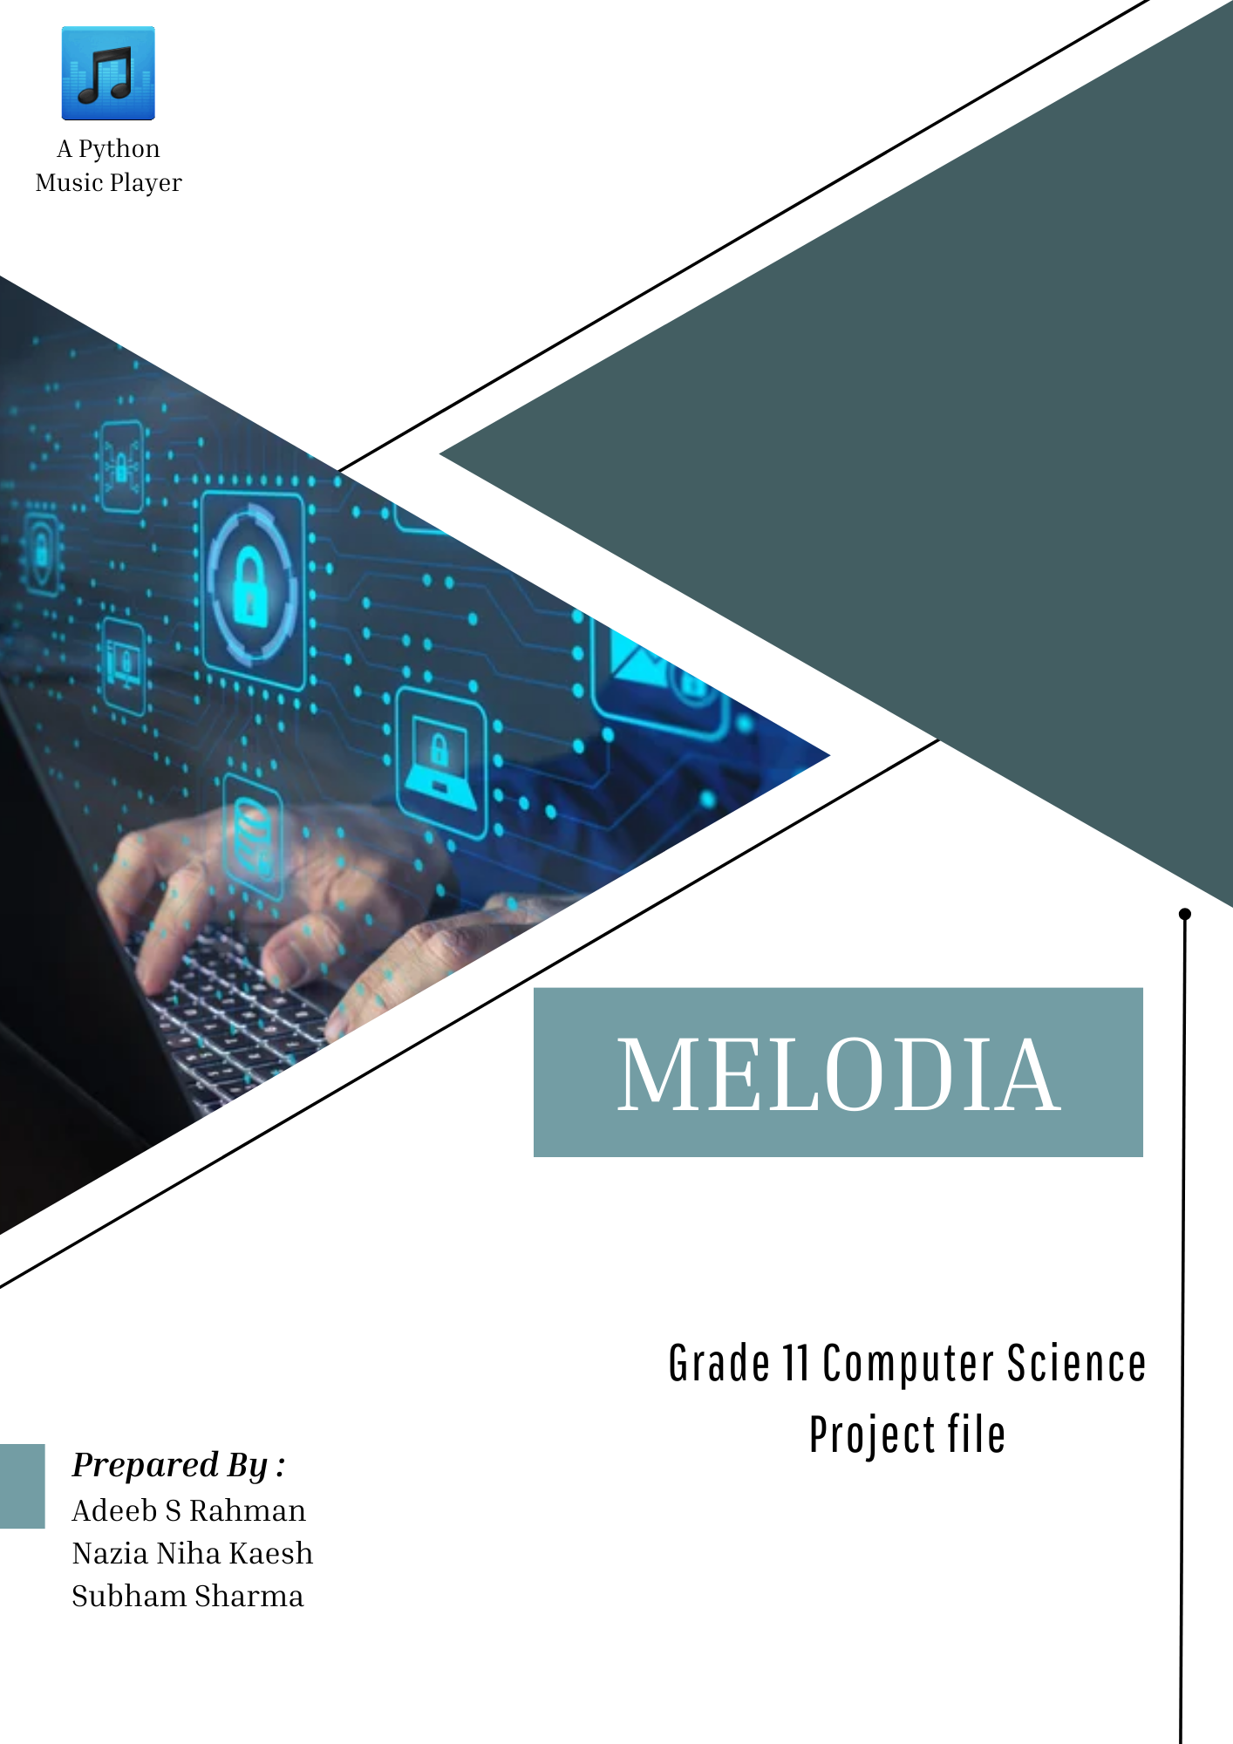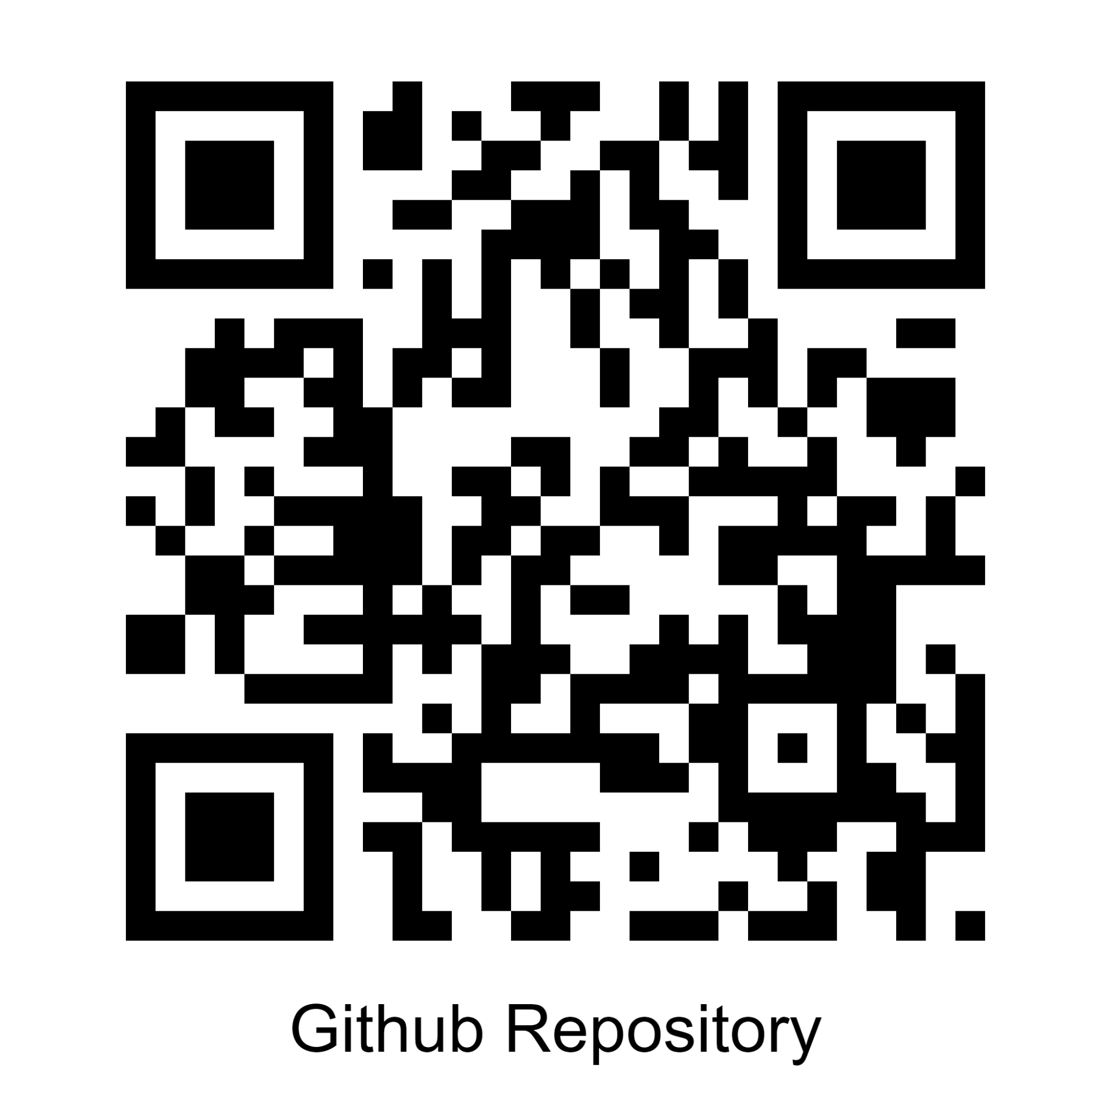

Table of Contents

**Acknowledgements 2**

**1: Introduction 3**

1.1 : Abstract 3

**2 : Front End 4**

2.1 : Screens 4

2.2 : Themes 5

**3 : Back End 6**

3.1 : Flow of Application 6

3.2 : Graphical Flowchart 6

3.3 : Libraries Used 7

3.4 : File Structure 8

3.5 : Main Functions 9

**4 : Screenshots 11**

4.1 : Flow of User Experience 11

**5 : Code 14**

5.2 : Melodia.py 14

5.3 : download.py 36

**6 : Conclusion 45**

6.1 : Achievements 45

6.2 : Improvements 45

6.3 : Contributors 45

**7 : References 46**



# Acknowledgements

The successful completion of this project by our team has been made possible through the invaluable support extended by various individuals.

Firstly, we express our sincere gratitude to our esteemed teacher, Mrs. Charu Negi, whose guidance and profound insights played an instrumental role in shaping the development of Melodia. Her constructive feedback and thoughtful suggestions have significantly contributed to refining and enhancing the project to its current polished state.

Additionally, we extend our appreciation to our classmates, whose unwavering encouragement, commendations, and constructive critiques propelled us forward throughout the project's evolution. Their active involvement in testing and diligent assistance in identifying and resolving bugs at various stages have been indispensable to the project's success.

We would like to express our sincere appreciation to John Elder from codemy.com for his outstanding tutorials, which played a vital role in the development of our project. His instructional content provided invaluable insights, guidance, and a solid foundation that greatly contributed to our understanding and successful implementation. We are grateful for the wealth of knowledge he shared, enriching our project and enhancing our skills in the process.

Lastly, we extend our heartfelt thanks to the reader for demonstrating a keen interest in our project. Your attention is a testament to the significance of our work, and we are truly honored by your engagement.

# 

Melodia

# **1: Introduction**

## *1.1 : Abstract*

Melodia is a python based, feature-rich music playing application that effectively serves as an offline mp3 player, providing users with a wide range of functionalities. It uses the Deezer API and youtube to provide users a way to listen to their favorite songs offline, by downloading the song on the device.It has a easy-to-use, modern UI.

The main features of the application include::

* Provide all standard issue features of a general MP3 player (pause, play, skip, autoplay, etc.)
* Ability to search and save music locally.
* Play, Create and Edit Playlists
* Interact with the app through a modern
* Various themes for user customization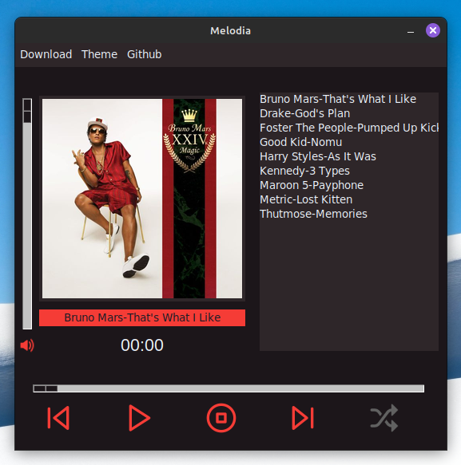

# 

# 

# 

# 

# 

# 

*Caption : Preview of Main Screen with “Magma” theme*

# **2 : Front End**

The program is fully based on python’s built-in Tkinter module. This was chosen due to ease of development, light-weight functionality, and user friendliness.

## *2.1 : Screens*

The program consists of two screens:

**1)** **Main Screen :**  Where users can see their downloaded songs and play them on their device, 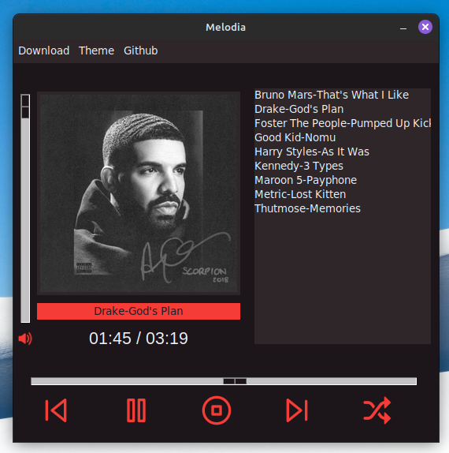

**2) Download Screen :** Where users can search for more songs to download to their device.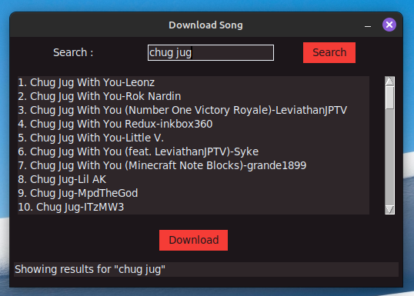

## *2.2 : Themes*

The application has various themes which add a sense of customization and personalization to the user experience. They can be changed dynamically. The themes include:

* Magma : Red coloured theme (Top-Left)
* Lush : Green coloured theme (Top-Right)
* Moonlit : Blue coloured theme (Bottom-Left)
* Nebula : Purple coloured theme (Bottom-Right)

(These themes also carry over to the download page)

The themes are shown below:

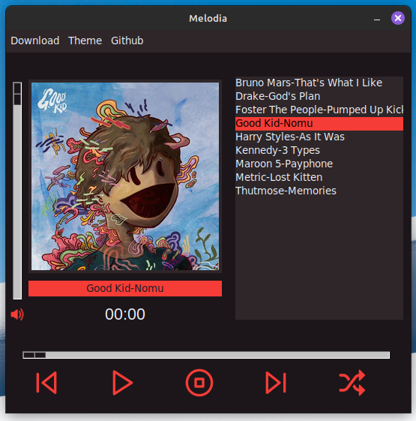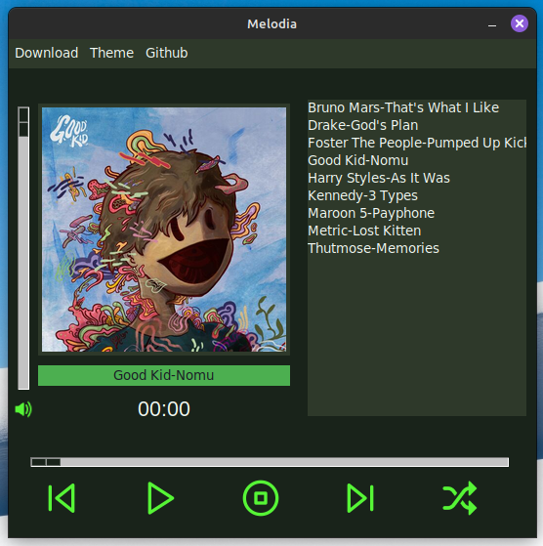

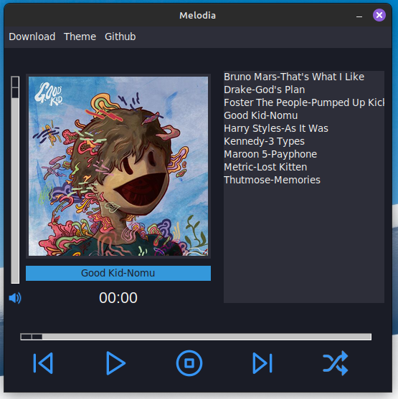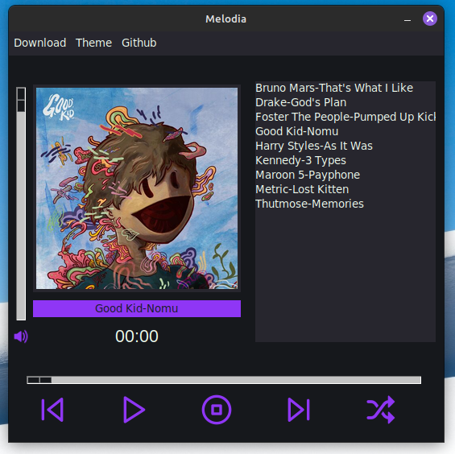

# **3 : Back End**

## *3.1 : Flow of Application*

The following is a breakdown of how our back end works :

* **Overview of Scripts:**
  + The project consists of two Python scripts: main.py and download.py.
  + main.py is responsible for the graphical user interface (GUI) using Tkinter.
  + download.py manages the download and conversion of music tracks.
* **API Integration:**
  + The Deezer API is used to fetch information about artists and tracks.
* **User Interaction:**
  + Users interact with a Tkinter GUI that prompts them to search for an artist.
* **Download Process:**
  + download.py takes care of downloading the chosen track from YouTube.
  + It then converts the downloaded MP4 file to MP3 using the moviepy library.
* **File Organization:**
  + The resulting MP3 file is stored in the "./music/" directory.
  + The script also downloads the associated album cover, placing it in "./music/albumCover/".
* **User Instructions:**
  + To use the application, users run main.py and provide their Deezer API credentials.
  + The GUI allows users to search for artists, select tracks, and initiate the download process.

## 

## *3.2 : Graphical Flowchart*

The following is a flowchart to explain the functionalities of the app.

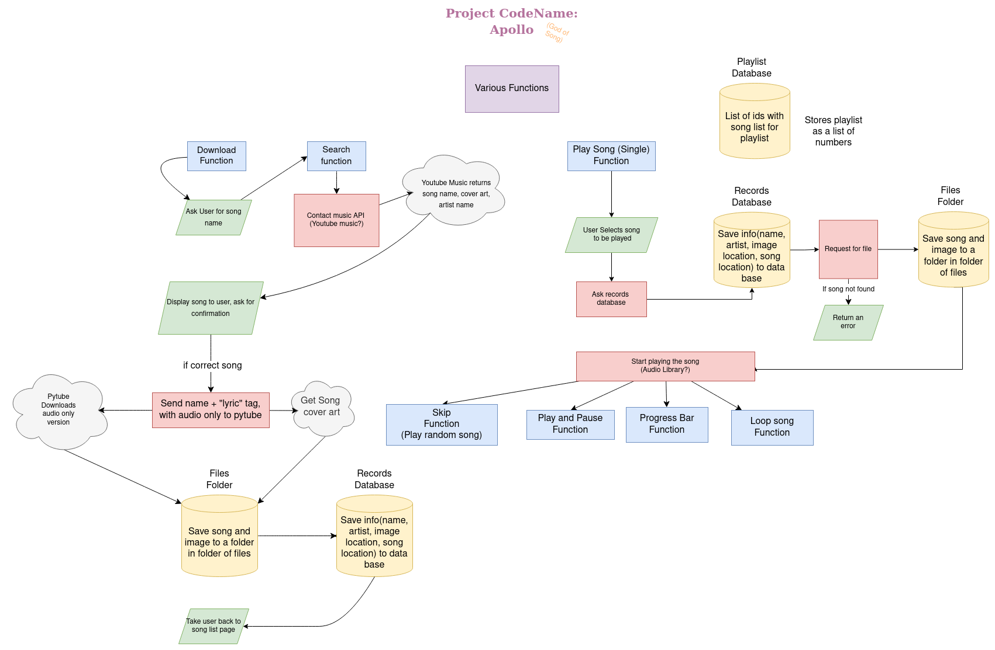

## 

## *3.3 : Libraries Used*

Modules from the following libraries are used. Information is provided with each to explain its function.

| **tkinter:** | This module is used for creating graphical user interfaces (GUIs) of the main window, buttons, labels, and other GUI elements. |
| --- | --- |
| **pygame:** | This module is used for handling audio playback. |
| **PIL(Python Imaging Library, now known as Pillow):** | This module is used for handling images. In this code, it's used for resizing and displaying album cover images. |
| **os:** | This module provides a way to interact with the operating system. It's used for file and directory operations, such as checking if a file or directory exists, opening a folder, deleting files, etc. |
| **time:** | This module provides various time-related functions. In this code, it's used for formatting time durations. |
| **tkinter.ttk:** | This submodule of tkinter provides a themed widget set used for styling the ttk.Scale widget (slider). |
| **mutagen.mp3:** | This module is used for reading metadata from MP3 files to get information about the length of a song. |
| **tkinter.messagebox:** | This submodule of tkinter is used for displaying message boxes. |
| **download:** | It contains functions related to downloading songs. |
| **webbrowser:** | This module is used to open a GitHub page. |
| **sys:** | This module is used to determine the platform (OS) the program is running on. |
| **random:** | This module is used for selecting a random song when in shuffle mode. |
| **deezer:** | This module is used to access information about artists, albums, tracks, and playlists on Deezer using deezer API. |
| **json:** | This module is used to store song lists and encode JSON format (serialization) and decoding JSON data into Python objects (deserialization). |
| **requests:** | This module is used for accessing deezer API and fetching URLs. |
| **pytube and pytube.search:** | This module is used to find song on youtube to be downloaded and downloads it |
| **moviepy.editor** | This module is part of the MoviePy library, which is used for converting the downloaded mp4 file into a mp3 file only |
| **shutil:** | This module is used to make folders for songs, etc. |
| **urllib:** | This module is used to get images from url. |
| **dotenv:** | It is used to store API information |

*Note : Deezer API credentials are securely stored in a .env file. To use the application, users run main.py and provide their Deezer API credentials.*

## *3.4 : File Structure*

The various files and directories are explained below :

| ./Config | color.txt is used for COLOR of slider in GUI |
| --- | --- |
| ./Music | Contains the mp3 files of the songs downloaded by the user |
| ./Music/albumcover | It is a subfolder of music containing all the album cover images of downloaded songs. |
| ./Sources | Contains images of the app logo, button icons, placeholder images, etc. |
| ./Sources/ctrlbtn | Contains image of all the buttons used in the GUI |
| ./Archive | Contains “Legacy Versions” of code for retrospective |
| ./Reference | This folder contains various files which are used as reference when coding, such as flow chart, font list, etc |
| .env_sample | A sample file. This directs the user on how the .env file should look like. |
| Requirements.txt | All necessary libraries to run the application. This has been put here for ease of installation. |

## *3.5 : Main Functions*

Following is a table explaining the functions used in the code.

| **master():** | updates the song duration on the GUI, handles the play state, controls shuffle and autoplay. |
| --- | --- |
| **songLengthGrabber():** | Retrieves the length of the currently playing song using the Mutagen library. |
| **changeName():** | Updates the displayed name of the currently playing track in the GUI. |
| **stop():** | Stops the currently playing song, cancels scheduled updates, and resets the play state. |
| **shuffleBtnFunc():** | Toggles the shuffle state and updates the shuffle button's image accordingly. |
| **randSelect():** | Selects a random track from the listbox, excluding the currently playing track, the one before, and the one after. |
| **mainBtnFunc(mainQuery):** | Controls the play/pause functionality of the main button. |
| **nextTrack(move):** | Plays the next or previous track based on the movement direction.(-1 or 1 respectively) |
| **changeCover(trackNum):** | Changes the album cover image based on the selected track. |
| **delSong():** | Stops the currently playing song, deletes the selected song and its cover, updates the GUI, and moves to the next track. |
| **getSongName(path):** | Converts a file path to a readable song name. |
| **getSongPath(name):** | Converts a song name to a file path. |
| **getSongCov(name):** | Converts a song name to an album cover image file path. |
| **slide(pos):** | Controls the slider for song duration and seeks the song to the specified position. |
| **openFolder():** | Opens the music folder. |
| **changeColor(scheme):** | Changes the color scheme of the GUI based on the selected theme. |
| **reloadTracks():** | : Reloads the list of tracks in the GUI. |
| **volSliderFunc(x):** | Controls the volume slider functionality and sets the volume for the Pygame mixer. |
| **openGithub():** | Opens the GitHub page of the project in the user's default browser. |

# **4 : Screenshots**

## *4.1 : Flow of User Experience*

1. The main screen upon installation :
2. Let’s download a song! 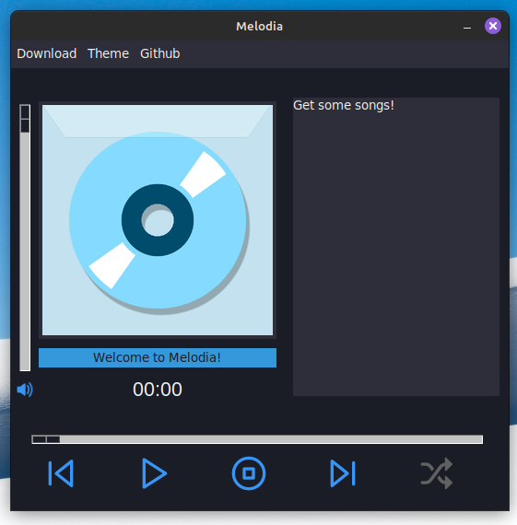

Download > Get Song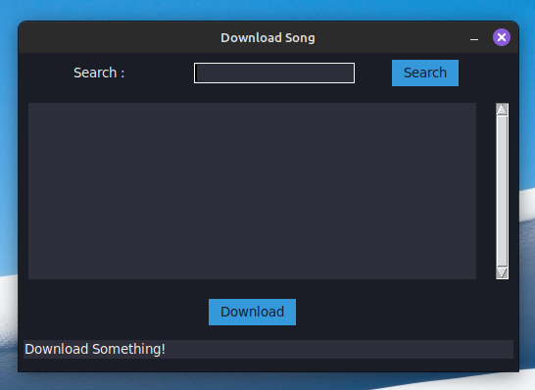

1. Searching and Downloading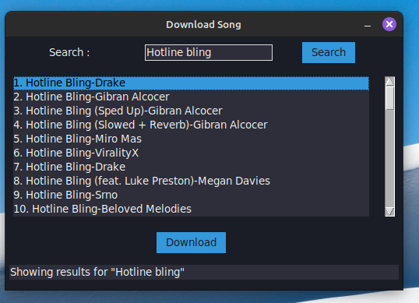
2. Now we can play it!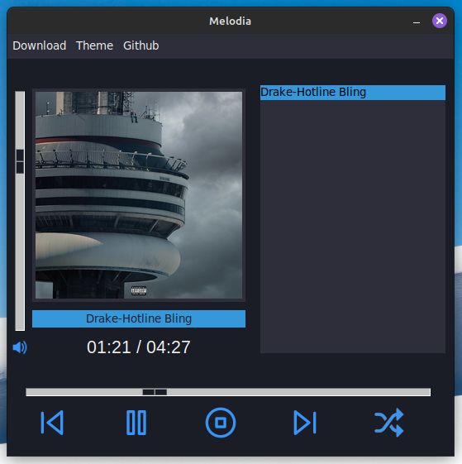
3. We can take advantage of the shuffle play/ Autoplay if we have many songs

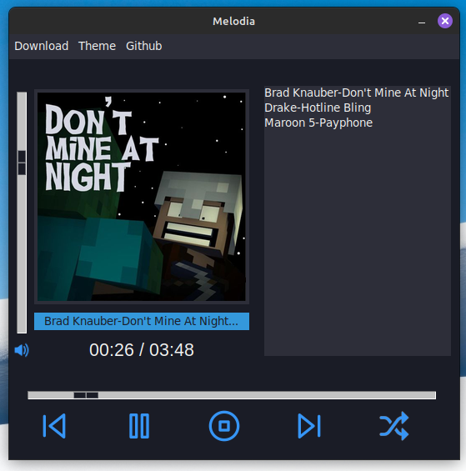

# **5 : Code**

## *5.2 : Melodia.py*

| # Import necessary libraries from tkinter import * import pygame from PIL import ImageTk, Image import os import time from mutagen.mp3 import MP3 import tkinter.ttk as ttk from tkinter import messagebox import download import webbrowser from sys import platform import random  # Define color constants bgMain = "#1A1C26" bgSec = "#2D2E39" fgMain = "#F4F4F2" accent = "#3498DB"  global USER_OS OS_LINUX=1 OS_MAC=2 OS_WIN=3 #Identify operating system if platform == "linux":  USER_OS = OS_LINUX  #Optimal Trackbox width is different  # for different operating systems  TBWidth= 28 elif platform == "darwin":  USER_OS = OS_MAC elif platform == "win32":  USER_OS = OS_WIN  TBWidth= 35  #Create the main tkinter screen screen = Tk() screen.title("Melodia") screen.configure(bg=bgMain)  #Modify the width of ttk slider (its too fat) s = ttk.Style() s.configure("Horizontal.TScale",sliderthickness=8) s.configure("Vertical.TScale",background=bgMain) s.configure("Horizontal.TScale",background=bgMain)  # Import and display program icon img = PhotoImage(file="./sources/icon.gif") screen.tk.call("wm", "iconphoto", screen._w, img) screen.iconphoto(True, img)  # Set window properties screen.resizable(0, 0) # Default 330x550 screen.geometry("540x480")  # Load control button images global playBtnImg, pauseBtnImg, stopBtnImg, frontBtnImg, backBtnImg, shuffleBtnImg, volIcon playBtnImg = PhotoImage(file="./sources/ctrlbtn/playBtnImgBlue.png") pauseBtnImg = PhotoImage(file="./sources/ctrlbtn/pauseBtnImgBlue.png") stopBtnImg = PhotoImage(file="./sources/ctrlbtn/stopBtnImgBlue.png") frontBtnImg = PhotoImage(file="./sources/ctrlbtn/frontBtnImgBlue.png") backBtnImg = PhotoImage(file="./sources/ctrlbtn/backBtnImgBlue.png") shuffleBtnImg = PhotoImage(file="./sources/ctrlbtn/shuffleBtnImgBlue.png") volIcon = PhotoImage(file="./sources/ctrlbtn/volContBlue.png")  #Shuffle button greyed out global shuffleBtnImgGray shuffleBtnImgGray = PhotoImage(file="./sources/ctrlbtn/shuffleBtnImgGray.png")   # Initialize global variable for play state, as well as what play state means global playState SONG_NOT_PLAYING = 0 SONG_IS_PLAYING = 1 SONG_IS_PAUSED = 2  # Initially, we dont want teh song to be playing playState = SONG_NOT_PLAYING  #Global variable for shuffle global shuffleState shuffleState = False  # Initialize the Pygame mixer pygame.mixer.init()  # Various functions used in the program # Function to change song duration (and auto play) def master():  global tracks  global playState   # If the song is stopped, dont do all this  if playState == SONG_NOT_PLAYING:  return   # Grab current time, edit the duration text (as integer)  currentDur = pygame.mixer.music.get_pos() / 1000   # Sometimes there is a error when song is played, so fix it  if currentDur < 0:  currentDur = 0   # Convert it into proper format  convCurrentDur = time.strftime("%M:%S", time.gmtime(currentDur))   # Getting the total time  songLen = songLengthGrabber()   # Convert again  convTotLen = time.strftime("%M:%S", time.gmtime(songLen))   # Small bug where current dur is not responsive of the first second  currentDur += 1   # Change the position and size of slider  slider.config(to_=songLen, value=int(slider.get()))   # If the song has finished playing  if int(slider.get()) == int(songLen):  # Show that the song is complete  durLabel.config(text=f"{convTotLen} / {convTotLen}")    #if shuffle mode is on, go to a random song  if shuffleState:  randSelect()  else:  #Otherwise, move on to the next song  nextTrack(1)   # Else, if its paused, we dont want to do anything  elif playState == SONG_IS_PAUSED:  pass   # If the slider hasnt moved  elif int(slider.get()) == int(currentDur):  # Change text  durLabel.config(text=f"{convCurrentDur} / {convTotLen}")  # Change the position of the slider to the current position  slider.config(to_=songLengthGrabber(), value=int(currentDur))   else:  # We need the position of the slider in time format  sliderConv = time.strftime("%M:%S", time.gmtime(int(slider.get())))   durLabel.config(text=f"{sliderConv} / {convTotLen}")   # Manually move the slider  slider.config(value=(slider.get() + 1))   # Run this again and again after 1 second  global secLoop  secLoop = screen.after(1000, master)   # Get length of song length def songLengthGrabber():  # Get file path of currently playing song  track = trackBox.get(ACTIVE)  track = getSongPath(track)   # Read song length with mutagen  songMutagen = MP3(track)  songLength = songMutagen.info.length  # Convert to proper format  return songLength   # Function to change name of track def changeName():  currentPlaying = trackBox.get(ACTIVE)  name = getSongName(currentPlaying)  # If song name is longer than 32 chars, shorten it  if len(name) > 32:  name = name[:32] + "..."   curTitle.configure(text=name)   # Function to stop the music def stop():  global playState   #If the song is already stopped, we error handle  if playState == SONG_NOT_PLAYING:  return  # Check to see if folder is empty  if emptyFolder:  messagebox.showerror(  "Error: No Songs!",  "Looks like you don't have any songs downloaded! Please download some",  )  return   global secLoop   # Stop the song in mixer  pygame.mixer.music.stop()   # Cancel the currently playing job  screen.after_cancel(secLoop)   # Change playState  playState = SONG_NOT_PLAYING   # Change all GUI elements  mainBtn.configure(image=playBtnImg)  mainBtn.photo = playBtnImg  slider.config(value=0)  durLabel.config(text=f"00:00")  #Functionality for shuffle button def shuffleBtnFunc():  global shuffleState   #If shuffle True, set shuffle false  if shuffleState:  shuffleState = False  shuffleBtn.config(image=shuffleBtnImgGray)  #print("Shuffle Off")    #If shuffle False, set shuffle ture  else:  shuffleState = True  shuffleBtn.config(image=shuffleBtnImg)  #print("Shuffle On")  #Random list box selector def randSelect() :  global playState  #Get a random index value for the listbox  #Make this not the same as current selection, the song before, or song after (doesnt FEEL random)  rand = random.randint(0,trackBox.size()-1)  while rand == trackBox.curselection()[0] or rand == trackBox.curselection()[0]-1 or rand == trackBox.curselection()[0]+1:  rand = random.randint(0,trackBox.size()-1)  #Clear current selection  trackBox.selection_clear(0, END)  #Set selection to our random one  trackBox.selection_set(rand) # Set the index  #Activate the random one  trackBox.activate(rand)   # Get the name of the next track, modify for file path, and update listbox selection  playTrack = trackBox.get(rand)  playTrack = getSongPath(playTrack)   # Change the album cover based on the selected track  changeCover(rand)   # Change the current title name, current play time  changeName()  durLabel.config(text=f"00:00")   #Set slider back to zero  slider.config(value=0)   # Cancel the currently playing job  screen.after_cancel(secLoop)   # Reset play state and simulate a button click to start playing the new track  playState = 0  mainBtnFunc(0)   # A function that controls teh working of the main play button def mainBtnFunc(mainQuery):  # Check to see if folder is empty  if emptyFolder:  messagebox.showerror(  "Error: No Songs!",  "Looks like you don't have any songs downloaded! Please download some",  )  return   global playState, tracks   # Copy the current play state to the local variable mainQuery  mainQuery = playState   # If the play state is 0 (initial or stopped)  if playState == SONG_NOT_PLAYING:  # Pause the music (if playing), #print a message, and get the selected track  pygame.mixer.music.pause()  # print("Play pressed first time")  track = trackBox.get(ACTIVE)   # Modify track name for file path and find its index in the tracks list  track = getSongPath(track)  trackIndex = tracks.index(track.replace("./music/", ""))   #Send slider to 0  slider.config(value=0)   # Load and play the selected track, update play state, and change album cover  pygame.mixer.music.load(track)  pygame.mixer.music.play(loops=0)  playState = SONG_IS_PLAYING  changeCover(trackIndex)   mainBtn.configure(image=pauseBtnImg)  mainBtn.photo = pauseBtnImg   # Change the current title name  changeName()   # Run the song duration fucntion when first played  master()   # If the play state is 1 (playing)  elif playState == SONG_IS_PLAYING:  # Pause the music,  # print a message, update play state, and change button image  pygame.mixer.music.pause()  playState = SONG_IS_PAUSED  mainBtn.configure(image=playBtnImg)  mainBtn.photo = playBtnImg   # If the play state is 2 (paused)  elif playState == SONG_IS_PAUSED:  # Unpause the music, #print a message, update play state, and change button image  pygame.mixer.music.unpause()  playState = SONG_IS_PLAYING  mainBtn.configure(image=pauseBtnImg)  mainBtn.photo = pauseBtnImg   # Function to play the next or previous track def nextTrack(move):  # Check to see if folder is empty  if emptyFolder:  messagebox.showerror(  "Error: No Songs!",  "Looks like you don't have any songs downloaded! Please download some",  )  return  try:  # Get the index of the currently selected track in the listbox  curTrack = trackBox.curselection()[0]  except IndexError:  messagebox.showerror(  "Error: Select a song!", "You have to click on the track you want to play"  )  return   # Stop the currently playing song  stop()   # If shuffle is on, just move to a shuffled song  if shuffleState:  randSelect()  return   global playState   # Calculate the index of the next track based on the movement direction  if curTrack == 0 and move == -1:  nextTrack = trackBox.size() - 1  elif curTrack == (trackBox.size() - 1) and move == 1:  nextTrack = 0  else:  nextTrack = trackBox.curselection()[0] + move   # Get the name of the next track, modify for file path, and update listbox selection  playTrack = trackBox.get(nextTrack)  playTrack = getSongPath(playTrack)   trackBox.selection_clear(0, END)  trackBox.activate(nextTrack)  trackBox.selection_set(nextTrack, last=None)   # Change the album cover based on the selected track  changeCover(nextTrack)   # Reset play state and simulate a button click to start playing the new track  playState = 0  mainBtnFunc(0)   # Change the current title name  changeName()   # Function to change the album cover image based on the selected track def changeCover(trackNum):  global curCover  albumCover = tracks[trackNum].replace(".mp3", "")  albumCover = f"./music/albumCover/{albumCover}-cover.jpg"  curCover = Image.open(albumCover)  curCover = curCover.resize((250, 250), Image.LANCZOS)  curCover = ImageTk.PhotoImage(curCover)  curCoverLabel.configure(image=curCover)  #Function to delete a song def delSong():  #Stop currently playing song  stop()   #Get path for song and cover  curSelect = trackBox.curselection()  if not curSelect:  messagebox.showerror(  "Select Song!",  "You must select the song to delete it"  )  return   selected = trackBox.get(curSelect[0])  selectedPath = getSongPath(selected)   selectedCoverPath = selectedPath.replace("./music/" , "").replace(".mp3", "")  selectedCoverPath = f"./music/albumCover/{selectedCoverPath}-cover.jpg"   #Delete cover, then image  os.remove(selectedCoverPath)  os.remove(selectedPath)   #Change album cover  curCover = Image.open("./sources/template.png")  curCover = curCover.resize((250, 250), Image.LANCZOS)  curCover = ImageTk.PhotoImage(curCover)  curCoverLabel.configure(image=curCover)   #Garbage collection  curCoverLabel.photo=curCover   #Reload track list  reloadTracks()   # #Move to next track  # nextTrack(1)  # Function to get song name def getSongName(path):  name = path.replace(".mp3", "")  name = name.replace("_", " ")   return name   # Function to get song path def getSongPath(name):  name = name.replace(" ", "_")  path = f"./music/{name}.mp3"  return path   # Function to get song album path def getSongCov(name):  path = name.replace(".mp3", "")  path = path.replace(" ", "_")  path = f"./music/albumCover/{path}-cover.jpg"  return path   # slider function def slide(pos):   if playState != SONG_IS_PLAYING:  pass  else:  track = trackBox.get(ACTIVE)  track = getSongPath(track)  # # Load and play the selected track, update play state, and change album cover  pygame.mixer.music.load(track)   curPos = slider.get()  pygame.mixer.music.play(loops=0, start=int(curPos))  slider.config(value=curPos)  #Open folder def openFolder():  print(USER_OS)  if USER_OS==OS_LINUX:  os.system('xdg-open "%s"' % "./music/")  elif USER_OS==OS_WIN:  os.startfile('.\\music')  elif USER_OS==OS_MAC:  pass  # Function to change color scheme def changeColor(scheme):  global playState  # Change the color pallette  # Col is for changing file path to button icons  if scheme == "BLUE":  bgMain = "#1A1C26"  bgSec = "#2D2E39"  fgMain = "#F4F4F2"  accent = "#3498DB"  col = "Blue"   elif scheme == "GREEN":  bgMain = "#19231A"  bgSec = "#2E392A"  fgMain = "#F2F8F2"  accent = "#4CAF50"  col = "Green"   elif scheme == "RED":  bgMain = "#1C161A"  bgSec = "#2E2629"  fgMain = "#EDF3FA"  accent = "#F53C36"  col = "Red"   elif scheme == "PURPLE":  bgMain = "#16181C"  bgSec = "#27262E"  fgMain = "#EEFAED"  accent = "#8F36F5"  col = "Purple"    # Change elements that use the background color  for i in bgMainBgList:  i.configure(bg=bgMain)   # Change elements that use the foreground color  for i in fgMainFgList:  i.configure(fg=fgMain)   # Change elements that use the secondary background color  for i in bgSecBgList:  i.configure(bg=bgSec)   # Change elements that use the accent color  # (not in a loop because we have to change different things)  trackBox.configure(selectbackground=accent)  curTitle.configure(bg=accent)   #Change cur cover border color  curCoverLabel.config(highlightbackground=bgSec)   # Change the file we're using for the images (it will now default to these)  global playBtnImg, pauseBtnImg, stopBtnImg, frontBtnImg, backBtnImg, shuffleBtnImg,volIcon   playBtnImg = PhotoImage(file=f"./sources/ctrlbtn/playBtnImg{col}.png")  pauseBtnImg = PhotoImage(file=f"./sources/ctrlbtn/pauseBtnImg{col}.png")  stopBtnImg = PhotoImage(file=f"./sources/ctrlbtn/stopBtnImg{col}.png")  frontBtnImg = PhotoImage(file=f"./sources/ctrlbtn/frontBtnImg{col}.png")  backBtnImg = PhotoImage(file=f"./sources/ctrlbtn/backBtnImg{col}.png")  shuffleBtnImg = PhotoImage(file=f"./sources/ctrlbtn/shuffleBtnImg{col}.png")  volIcon= PhotoImage(file=f"./sources/ctrlbtn/volCont{col}.png")   # Change the button images   #If song is playing, pause button image should be used  if playState == SONG_IS_PLAYING:  mainBtn.configure(image=pauseBtnImg)  #Stop Garbage collection  mainBtn.photo = pauseBtnImg  else:  #Otherwise use play button  mainBtn.configure(image=playBtnImg)  #Stop Garbage collection  mainBtn.photo = playBtnImg   #if shuffle is on, change the image  if shuffleState:  shuffleBtn.configure(image=shuffleBtnImg)  #Stop Garbage collection  shuffleBtn.photo = shuffleBtnImg   stopBtn.configure(image=stopBtnImg)  frontBtn.configure(image=frontBtnImg)  backBtn.configure(image=backBtnImg)  volSliderLabel.configure(image=volIcon)   # Stop garbage collection (if this code is not here,  # the loaded images are deleted before they are used)  mainBtn.photo = playBtnImg  stopBtn.photo = stopBtnImg  frontBtn.photo = frontBtnImg  backBtn.photo = backBtnImg  volSliderLabel.photo = volIcon   #Change the background color of the slider  s.configure("Vertical.TScale",background=bgMain)  s.configure("Horizontal.TScale",background=bgMain)   # Change this to new default  defaultColor = open("./config/COLOR.txt", "r+")  # Erase the file  defaultColor.truncate(0)  # Write new default  defaultColor.write(scheme)  defaultColor.close()   # Function to reload the track box def reloadTracks():  # Redefine tracks list  global tracks  tracks = []  for name in os.listdir("./music"):  if name in [".gitignore", "albumCover"]:  continue  tracks.append(name)  tracks = sorted(tracks)   global emptyFolder  if len(tracks) == 0:  tracks = ["Get some songs!"]  # This variable tracks if the directory is empty  emptyFolder = True  else:  emptyFolder = False   # Clear current trackbox  trackBox.delete(0, "end")   # Add everything back  for name in tracks:  name = name.replace(".mp3", "")  name = name.replace("_", " ")  trackBox.insert("end", name)  #Volume slider funtion def volSliderFunc(x):  vol= volSlider.get()  pygame.mixer.music.set_volume(volSlider.get())  #volSliderLabel.config(text=f"{int(pygame.mixer.music.get_volume()*100)}%")  # printpygame.mixer.music.get_volume()  # pass  #Link to github page def openGithub():  webbrowser.open('https://github.com/Arctican4Real/Melodia')  #Auto play capability  ### UI CODE ###  # Code for main menu bar settings = Menu(screen, bg=bgSec, fg=fgMain, bd=0) screen.config(menu=settings)  # Code for download button on menu bar downloadMenu = Menu(settings, bg=bgMain, fg=fgMain, bd=0,tearoff="off") settings.add_cascade(label="Download", menu=downloadMenu)  # Button to download songs downloadMenu.add_command(label="Get Song", command=lambda:download.downloadSong(screen)) # Button to reload the tracks downloadMenu.add_command(label="Reload Tracks", command=reloadTracks) # Add folder button downloadMenu.add_command(label="Open Folder", command=openFolder) # Delete song downloadMenu.add_command(label="Delete Song", command=delSong)   # Code for themes button on menu bar themeMenu = Menu(settings, bg=bgMain, fg=fgMain, bd=0, tearoff="off") settings.add_cascade(label="Theme", menu=themeMenu) themeMenu.add_command(label="Magma", command=lambda: changeColor("RED")) themeMenu.add_command(label="Lush", command=lambda: changeColor("GREEN")) themeMenu.add_command(label="Moonlit", command=lambda: changeColor("BLUE")) themeMenu.add_command(label="Nebula", command=lambda: changeColor("PURPLE"))  #Github page link settings.add_command(label="Github", command=openGithub)  # Frames left_frame = Frame(screen, bg=bgMain) left_frame.grid(row=0, column=1, padx=(0,5), pady=(0,0), sticky="ew")  right_frame = Frame(screen, bg=bgMain) right_frame.grid(row=0, column=2, padx=(0,10), pady=(0,0), sticky="ew")  down_frame = Frame(screen, bg=bgMain) down_frame.grid(row=1, column=0, padx=22, pady=0,sticky="ew",columnspan=4)  btnDiv = Frame(screen, bg=bgMain) btnDiv.grid(row=2,column=0,padx=22,pady=10,sticky="ew",columnspan=4)  # Add weight to the rows and columns for right_frame screen.grid_rowconfigure(0, weight=1) screen.grid_columnconfigure(1, weight=1) right_frame.grid_rowconfigure(0, weight=1) right_frame.grid_columnconfigure(1, weight=1)  # Create a listbox to display tracks trackBox = Listbox(  right_frame,  bg=bgSec,  fg=fgMain,  borderwidth=0,  highlightthickness=0,  selectbackground=accent,  selectborderwidth=0,  width=TBWidth,  height=18,  activestyle="none",  selectmode=SINGLE ) trackBox.grid(row=0, column=0, sticky="ew", padx=0,pady=(21,30))  # Defualt to the first track in the listbox trackBox.activate(0) trackBox.selection_set(0)  # Initially load the tracks reloadTracks()  # Load the first cover from the folder if not emptyFolder:  albumCover = getSongCov(trackBox.get(0)) # If the folder is empty, get default cover else:  albumCover = "./sources/template.png"  volSliderFrame=Frame(screen, bg=bgMain) volSliderFrame.grid(row=0,column=0,padx=5)  volSliderLabel = Label(  volSliderFrame,  borderwidth=0,  highlightthickness=0,  bd=0,  bg=bgMain,  fg=fgMain,  image=volIcon  ) volSliderLabel.grid(column=0, row=2)  # Volume control Slider volSlider = ttk.Scale(  volSliderFrame,  from_=1,  to=0,  orient=VERTICAL,  value=100,  length=290,  command=volSliderFunc  ) s=ttk.Style() s.configure("Vertical.TScale",sliderthickness=10) volSlider.grid(column=0,row=0,pady=(0,10),sticky="ns")  #Cover art global curCover curCover = Image.open(albumCover) curCover = curCover.resize((250, 250), Image.LANCZOS) curCover = ImageTk.PhotoImage(curCover)  curCoverLabel = Label(left_frame,image=curCover, borderwidth=0, highlightthickness=4, highlightbackground=bgSec, bg=bgMain) curCoverLabel.grid(pady=10,column=1,row=0)  # Display the song duration durLabel = Label(  left_frame,  text="00:00",  borderwidth=0,  highlightthickness=0,  bd=0,  bg=bgMain,  fg=fgMain,  width=20,  height=1,  font=("Arial", 16), )  durLabel.grid(row=2,column=1, columnspan=1,pady=10)  # Slider for song duration slider = ttk.Scale(  down_frame,  from_=0,  to=100,  orient=HORIZONTAL,  value=0,  length=470,  #command=slide, ) slider.grid(column=3,pady=0,ipadx=10,columnspan=4)  #Only trigger the slide event when slider stops moving slider.bind("<ButtonRelease-1>", slide)  # Text box for song length if not emptyFolder:  firstTrack = getSongName(trackBox.get(0)) # Default variable if no songs else:  firstTrack = "Welcome to Melodia!"  # Display the current song name curTitle = Label(left_frame, text=firstTrack, bd=1, bg=accent, fg=bgMain) curTitle.grid(row=1,column=1, ipady=0, pady=0,sticky="ew")  #Buttons  # Create control buttons mainBtn = Button(  btnDiv,  image=playBtnImg,  borderwidth=0,  command=lambda: mainBtnFunc(playState),  bg=bgMain,  highlightthickness=0,  bd=0,  relief=SUNKEN,  activebackground=bgSec ) stopBtn = Button(  btnDiv,  image=stopBtnImg,  borderwidth=0,  command=stop,  bg=bgMain,  highlightthickness=0,  bd=0,  relief=SUNKEN,  activebackground=bgSec ) backBtn = Button(  btnDiv,  image=backBtnImg,  borderwidth=0,  command=lambda: nextTrack(-1),  bg=bgMain,  highlightthickness=0,  bd=0,  relief=SUNKEN,  activebackground=bgSec ) frontBtn = Button(  btnDiv,  image=frontBtnImg,  borderwidth=0,  command=lambda: nextTrack(1),  bg=bgMain,  highlightthickness=0,  bd=0,  relief=SUNKEN,  activebackground=bgSec ) shuffleBtn = Button(  btnDiv,  image=shuffleBtnImgGray,  borderwidth=0,  command=shuffleBtnFunc,  bg=bgMain,  highlightthickness=0,  bd=0,  relief=SUNKEN,  activebackground=bgSec )  # Grid layout for control buttons backBtn.grid(row=0, column=0, padx=(10,60), pady=(0,10)) mainBtn.grid(row=0, column=1, padx=(0,60), pady=(0,10)) stopBtn.grid(row=0, column=2, padx=(0,60), pady=(0,10)) frontBtn.grid(row=0, column=3, padx=(0,60), pady=(0,10)) shuffleBtn.grid(row=0, column=4, padx=(0,10), pady=(0,10))  # A list containing elements which use saved colors bgMainBgList = [  screen,  downloadMenu,  themeMenu,  durLabel,  curTitle,  btnDiv,  mainBtn,  stopBtn,  backBtn,  frontBtn,  shuffleBtn,  settings,  left_frame,  right_frame,  down_frame,  btnDiv,  volSliderLabel,  volSliderFrame ] fgMainFgList = [trackBox, settings, downloadMenu, themeMenu, durLabel] bgSecBgList = [settings,trackBox]  # Get the default color defaultColor = open("./config/COLOR.txt", "rt") changeColor(defaultColor.read()) defaultColor.close()  #initiate screen.mainloop() |
| --- |

## 

## *5.3 : download.py*

| # Song search API wrapper import deezer # Access to Web browser import webbrowser # To conver JSON files import json # To open URLs import requests # To download form youtube from pytube import YouTube # To search youtube from pytube import Search # To convert MP4 to MP3 from moviepy.editor import * # To make folders import shutil # To download images import urllib # Accessing API password import os from dotenv import load_dotenv  # Tkinter import tkinter as tk from tkinter import ttk from tkinter import messagebox from tkinter.ttk import *  # Library for adding cover art to mp3 import eyed3 from eyed3.id3.frames import ImageFrame   # Get the App id and app secret try:  load_dotenv()  app_id = os.environ["APP_ID"]  app_secret = os.environ["APP_SECRET"] except KeyError:  print("FATAL ERROR :")  print("Uh Oh! You don't have an API key, so I can't access Deezer!")  print("Did you get a env file with API keys")  raise SystemExit(0)  # Log into deezer with our app id (username) and password(app secret) client = deezer.Client(  app_id=app_id,  app_secret=app_secret,  # This is so results are in English only  headers={"Accept-Language": "en"}, ) # This is a function to turn MP4 files into just audio MP3 files def mp4_to_mp3(mp4, mp3):  mp4_without_frames = AudioFileClip(mp4)  mp4_without_frames.write_audiofile(mp3)  mp4_without_frames.close()   # This function modifies the mp3 to add album cover art def addAlbumCover(audio, image, title, albumName, artist):  audiofile = eyed3.load(audio)  if audiofile.tag == None:  audiofile.initTag()  audiofile.tag.images.set(3, open(image, "rb").read(), "image/jpeg")  audiofile.tag.save()  audiofile.tag.title = title  audiofile.tag.album = albumName  audiofile.tag.album_artist = artist  audiofile.tag.save(version=eyed3.id3.ID3_V2_3) def download_button_clicked():  status_bar.config(text=f"Finding Track...")  ws.update_idletasks()  global deezerTrack  # Get currently selected song  chosenIndex = results_listbox.curselection()[0]  chosenTrack = deezerTrack[chosenIndex]  # This is the song name and artist name, replacing spaces with underscores, and replace the /  songName = chosenTrack.title_short.replace(" ", "_").replace("/", "-")  artistName = chosenTrack.artist.name.replace(" ", "_").replace("/", "-")  # This is the song name and artist name, replacing spaces and slashes with underscores  songName = chosenTrack.title_short.replace(" ", "_").replace("/", "_")  artistName = chosenTrack.artist.name.replace(" ", "_").replace("/", "_")   # Search for the Artist + Song Name + "Audio" on youtube with pytube  # Example - "Avicii Waiting for love audio" is searched  searchList = Search(songName + artistName + " audio")  # Get the first video from search result  firstResult = str(searchList.results[0])  status_bar.config(text=f"Getting Song...")  ws.update_idletasks()  # These two lines get the video id, and uses that to make the link  # Basically, get the link  vidID = firstResult.split("=")[1].replace(">", "")  finalLink = "https://www.youtube.com/watch?v=" + vidID   # This is a path to the folder where our song will be saved  # It names the folder the title of the song, replacing spaces with underscores  # Example - "Waiting_for_love"  path = "./music/" # + str(chosenTrack["title"]).replace(" ", "_")   # Make the folder  # os.mkdir(path)  status_bar.config(text=f"Downloading song...")  ws.update_idletasks()   # Use the link we found before to download the video at lowest resolution (we only need audio) to the folder  target = YouTube(finalLink)   # This downloads the MP4 file inside the folder we made  target.streams.filter(file_extension="mp4").first().download(  path, filename=songName + ".mp4"  )   status_bar.config(text=f"Changing files to MP3...")  ws.update_idletasks()  # This will convert our MP4 to MP3 using that function  mp4_to_mp3(f"{path}/{songName}.mp4", f"{path}/{artistName}-{songName}.mp3")   # Delete the original file to save on space  os.remove(f"{path}/{songName}.mp4")   # These two lines get the cover art of the album from the API, and download it to our folder  coverImg = chosenTrack.album.cover_big   status_bar.config(text=f"Getting cover image...")  ws.update_idletasks()  # This will save the cover image as "./Downloads/ARTISTNAME-SONGNAME-COVER.jpg"  # Example - ./Downloads/Avicii-Waiting_for_love-cover.jpg  urllib.request.urlretrieve(  coverImg, f"{path}/albumCover/{artistName}-{songName}-cover.jpg"  )   # Change the cover art of the mp3  audio = f"{path}/{artistName}-{songName}.mp3"  image = f"{path}/albumCover/{artistName}-{songName}-cover.jpg"  addAlbumCover(  audio,  image,  chosenTrack.title_short,  chosenTrack.album.title,  chosenTrack.artist.name,  )   status_bar.config(text=f'Downloading Complete! Click "Reload Tracks" on main menu')   def searchButton():  status_bar.config(text=f"Searching...")  ws.update_idletasks()  # Ask for artist  query = modify.get()   # Error handling for empty  if len(query) == 0:  return   # Use deezer to search for this artist  global deezerTrack  deezerTrack = client.search(query)   # Clear listbox  results_listbox.delete(0, "end")   cunt = 0  for result in deezerTrack:  # Limiting searches to top 50 results  if cunt >= 50:  break  results_listbox.insert(  "end", str(cunt + 1) + ". " + result.title_short + "-" + result.artist.name  )  cunt += 1   status_bar.config(text=f'Showing results for "{query}"')  ws.update_idletasks()   # This is the code for our new window def downloadSong(main):  # Generate scheme  defaultColor = open("./config/COLOR.txt", "rt")  scheme = defaultColor.read()  defaultColor.close()   if scheme == "BLUE":  bgMain = "#1A1C26"  bgSec = "#2D2E39"  fgMain = "#F4F4F2"  accent = "#3498DB"  col = "Blue"   elif scheme == "GREEN":  bgMain = "#19231A"  bgSec = "#2E392A"  fgMain = "#F2F8F2"  accent = "#4CAF50"  col = "Green"   elif scheme == "RED":  bgMain = "#1C161A"  bgSec = "#2E2629"  fgMain = "#EDF3FA"  accent = "#F53C36"  col = "Red"   elif scheme == "PURPLE":  bgMain = "#16181C"  bgSec = "#27262E"  fgMain = "#EEFAED"  accent = "#8F36F5"  col = "Purple"   # Create main window  global ws  ws = tk.Toplevel(main)  ws.title("Download Song")  # Set the geometry of the main window (width x height)  ws.geometry("510x325")  ws.resizable(0, 0)  ws.configure(bg=bgMain)   # Create a StringVar to hold the text input value  text = tk.StringVar()   # Create a frame to hold other widgets  Frm = tk.Frame(ws)   # Configure the column weights of the main window to manage space distribution  ws.columnconfigure(0, weight=1)  ws.columnconfigure(1, weight=1)  ws.columnconfigure(2, weight=1)  # Create an entry widget for text input, linked to the text StringVar  global modify  modify = tk.Entry(  ws,  textvariable=text,  bg=bgSec,  fg=fgMain,  bd=0,  highlightcolor=fgMain,  highlightthickness=1,  )  # Text entry box and Submit button in the same row  modify_label = tk.Label(  ws,  text="Search : ",  borderwidth=0,  bg=bgMain,  fg=fgMain,  highlightthickness=0,  bd=0,  )  modify_label.grid(row=0, column=0, pady=10, padx=10, sticky=tk.E)  modify.grid(row=0, column=1, pady=10, padx=10, sticky=tk.E)  modify.focus()   # Create a button that will call the find function when pressed  buttn = tk.Button(  ws,  text="Search",  borderwidth=0,  bg=accent,  fg=bgMain,  highlightthickness=0,  bd=0,  command=searchButton,  )   # Place the button in the grid layout  buttn.grid(column=2, row=0, padx=5, pady=5)   global results_listbox  results_listbox = tk.Listbox(  ws,  selectmode=tk.SINGLE,  bg=bgSec,  fg=fgMain,  borderwidth=0,  highlightthickness=0,  selectbackground=accent,  selectborderwidth=0,  )   results_listbox.grid(  row=1, column=0, columnspan=3, pady=10, padx=10, sticky=tk.W + tk.E  )   scrollbar = tk.Scrollbar(ws, orient=tk.VERTICAL, command=results_listbox.yview)  scrollbar.grid(row=1, column=4, pady=10, padx=10, sticky=tk.W + tk.N + tk.S)  results_listbox.config(yscrollcommand=scrollbar.set)  contacts = []   # Download button  download_button = tk.Button(  ws,  text="Download",  command=download_button_clicked,  borderwidth=0,  bg=accent,  fg=bgMain,  highlightthickness=0,  bd=0,  )  download_button.grid(row=2, pady=10, columnspan=4)   # Status bar at the bottom  global status_bar  status_bar = tk.Label(  ws,  text="Download Something!",  bd=1,  relief=tk.SUNKEN,  anchor=tk.W,  borderwidth=0,  fg=fgMain,  bg=bgSec,  )  status_bar.grid(row=3, columnspan=5, sticky="ew", padx=5, pady=5)   ws.mainloop() |
| --- |

# 

# **6 : Conclusion**

## *6.1 : Achievements*

Through this project we learned how to use a tkinter based GUI with a comprehensive backend suite. We were able to learn about various python libraries to manage our backend, such as pygame Mixer, Mutagen, Shutil, movie py etc. We also learned how to contact an API (Deezer) which enabled us to get the data.

## *6.2 : Improvements*

Various features can be added to enhance the user experience. These include:

* Change to a more reliable music search API key
* Create database and store more information about the Tracks
* Implement Playlists
* Add option to search both tracks or album
* Connect music GUI to Download feature
* Add secret features
* Autoplay, Themes, Loops

We plan to add these in the upcoming release.

## *6.3 : Contributors*

* Adeeb S Rahman
* Nazia Niha Kaesh
* Subham Sharma

# 

# **7 : References**

<https://www.youtube.com/watch?v=djDcVWbEYoE&list=PLXLYwvNGGPoUzjKiGvuXm8qeiOYMnFria>

-Used for GUI of the project and as a reference for how to play music using pygame.

<https://anzeljg.github.io/rin2/book2/2405/docs/tkinter/index.html>

- used for General tutorials on tkinter and resolving many queries in the project.

<https://developers.deezer.com/>

- API used in a project.

<https://deezer-python.readthedocs.io/en/stable/>

-Deezer API Wrapper

<https://coolors.co/>

Color palette

<https://www.flaticon.com/free-icons/mp3-player>

Used for icons in GUI

<https://icons8.com/>

Also used for icons in GUI.

The full Github repository can be found in the following link:

<https://github.com/Arctican4Real/Melodia>